AD-HOC REPORT

If required a Research Manager or Research Administrator will request an Ad-hoc report. When such a request is made, payments with automatically be put on hold. An email is sent at least two months in advance, informing you that the Dutch Heart Foundation requests an Ad-hoc report. Please follow the steps to upload the report.

Submitting an Ad-hoc report
Please log into your account and open your dashboard. In the top right corner, you can find the Report button. After navigating to the list of reports, please find and open the report with the corresponding application reference number. You will find the number in your e-mail.
- Please fill in all the details required. If required, use the ‘Save Draft’ button to save any information in case the report is not submitted right away.
- Upload the report

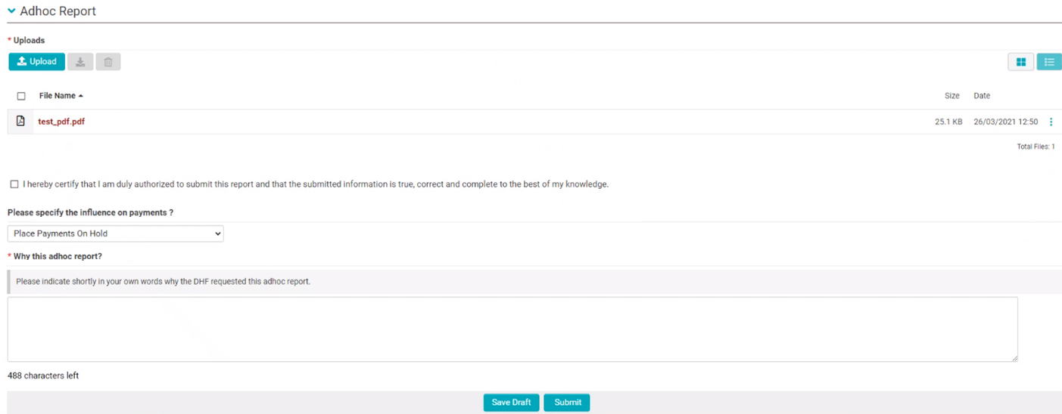

- Next, please submit the report using the ‘Submit’ button. The report is now sent to the corresponding staff member who will review the report.

Resubmitting Revisions
After the report is examined, it will be either approved or additional information will be required. If applicable, an external advisor will inform the staff members how to proceed. The corresponding external advice will be added to the Ad-hoc report.
- If necessary, please re-edit the report if a request is made for a revision.
- Next, please re-submit your report.

Approval
- If the report has been approved, you will receive a conformation.
- The payments will be rescheduled according to the corresponding timeline.

