PROGRESS REPORT
If required a Research Manager or Research Administrator will request a Progress report. When such a request is made, payments will automatically be put on hold. You will receive an email at least two months in advance, informing you that the Dutch Heart Foundation requests a Progress report. Please follow these steps to fill in the progress report.

Submitting a Progress report
Please log into your account and open your dashboard. In the top right corner, you can find the Report button. Navigate to the list of reports and open the report with the corresponding application reference number. This reference number is mentioned in the email we sent.
- Please fill in all the details required. If you are not submitting the report right away, please use the ‘Save Draft’ button to save your information.

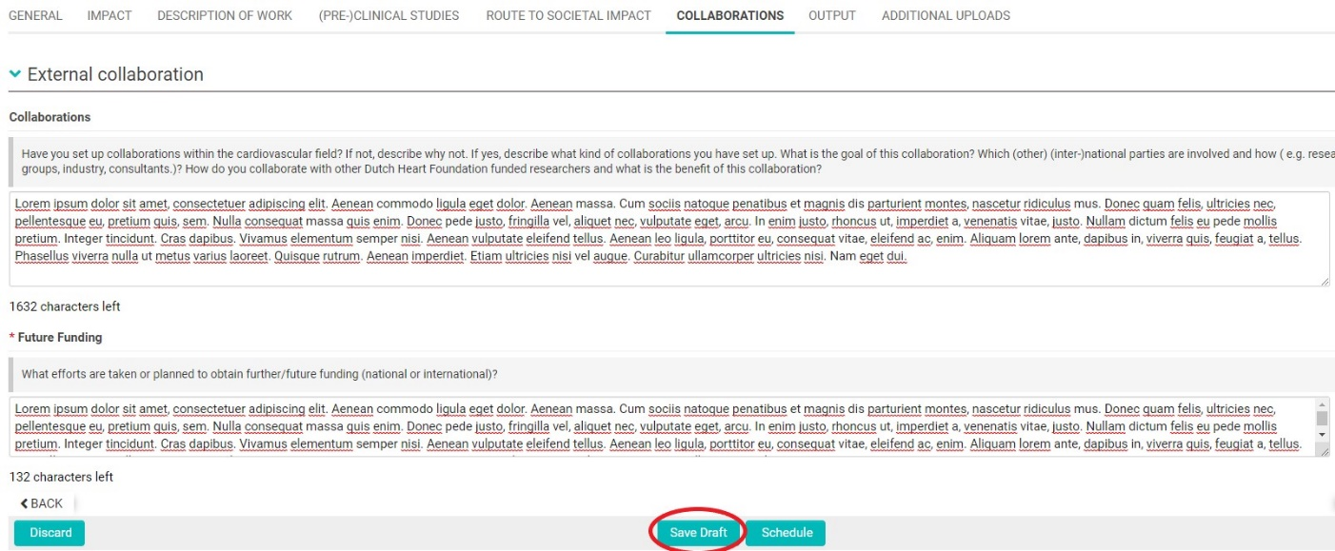

- If required, please also submit a Financial Report. Please note that the financial report has to be submitted BEFORE the scientific report.
- Next, submit the report using the ‘Submit’ button.

Resubmitting Revisions
After the report is examined, it will be either approved or additional information will be required. If applicable, an external advisor will inform the staff members on how to proceed. The corresponding external advice will be added to the Progress report.
- If necessary, please re-edit the report.
- Next, please re-submit your report.

Approval
- If the report has been approved, you will receive a conformation.
- The payments will be rescheduled according to the corresponding timeline and the application status is automatically changed to Granted Pending Schedule Review.

