MIDTERM REPORT

When your project is almost halfway, we will remind you of the expected midterm report.
The midterm report contains information about the (preliminary) results of the research project.
We will often also schedule a financial report when we schedule a midterm report. Two months before the deadline of the midterm report, both reports will be available in Cavaris.
If the midterm report is not approved, the payment schedule is put on hold until the report has been received, reviewed, adjusted ánd approved.

Submitting a Midterm Report
- To open a report, navigate to the ‘Reports home’ section located in the top right corner.
- Next, navigate to the menu button ‘Pending Reports’ (see example).

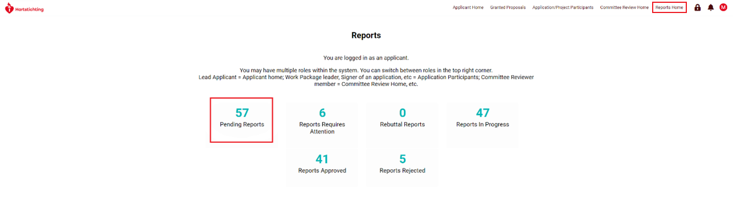
- After opening the report, fill in the required fields of the report.
- If the deadline has passed, the midterm report will not be available in Cavaris anymore. In that case, please call or email us!
- In order to submit a midterm report, first submit the financial report made available with the midterm report.

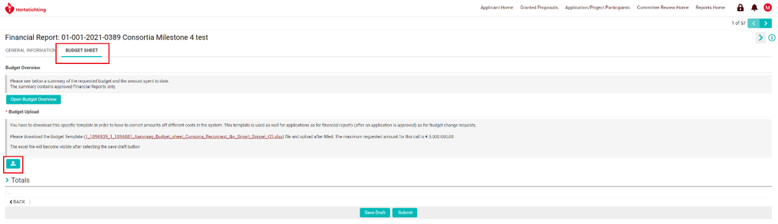

- To find an overview of the reports, navigate to the tab ‘General Information’.
- If all the information (required fields) has been filled in, please upload the financial report by navigating to the ‘Budget sheet’ tab.
- Submit the Financial report using the ‘Submit’ button.

Report Reviews
The reports are reviewed:.
- If the budget sheet requires a revision, we will contact you by email.
- If applicable, navigate to the report to edit the budget sheet using the same tab as mentioned in the previous instruction.
- When revisions of the midterm report are required, navigate to the same tab as mentioned in the previous instructions (‘Reports home’ > ‘Pending Reports’) where the report can be found.

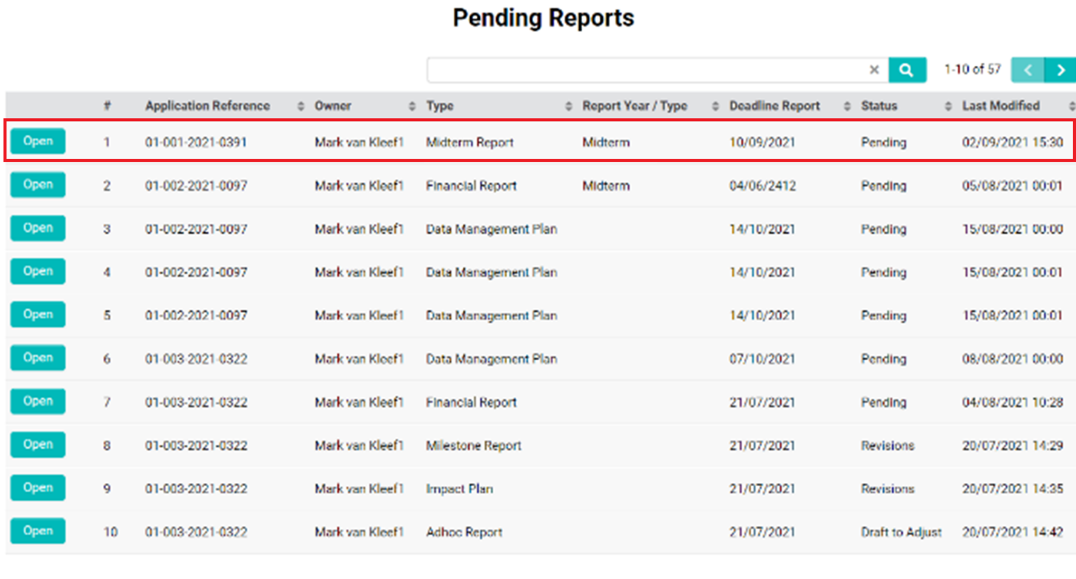

Please notice if any specific fields have already been filled in. If so, this may have been done deliberately by one of our staff members.
- Please fill in the missing details and edit empty fields and/or fields which do not contain the correct information.
- Save the information using the ‘Save draft’ button. Are you sure everything is filled in, please press the ‘Submit’ button.
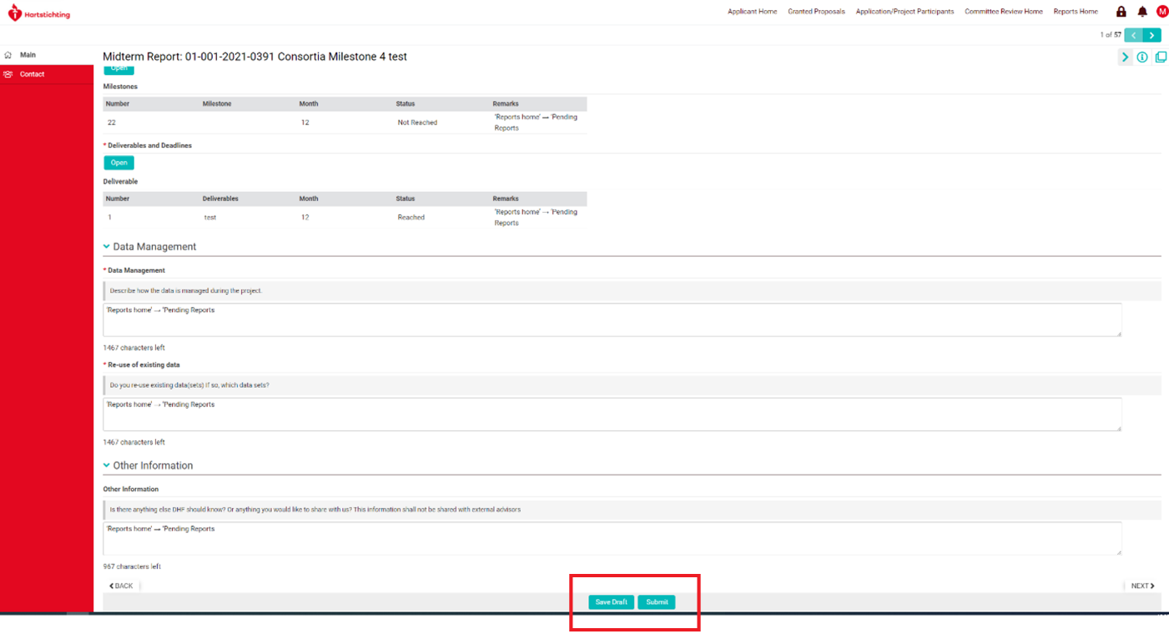
- If required, the Midterm report is sent to a review committee and/or external reviewer to review the report.

