# MANUAL DASHBOARD AND LISTVIEWS

This instruction set explains how to find your application, reports and reviews.

Inhoud

Roles in the system 1

Dashboard Applicant Home 1

Dashboard Granted Proposals 3

Dashboard Application/Project participants 4

Dashboard Committee Review Home 5

Dashboard Reviews 5

Dashboard Reports Home 6

# Roles in the system

When you login into the system, you will first be guided to the homepage. On the top right corner of the screen, different dashboards can be seen.

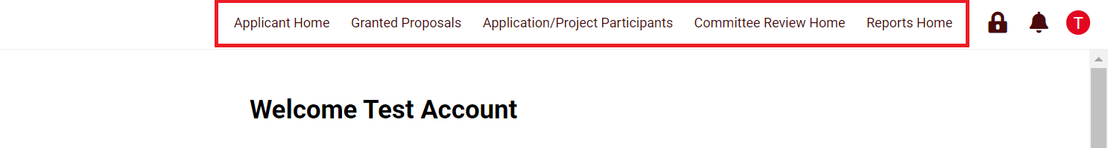

Depending on the role you’ve been assigned to, you can find your documents in different dashboards. There are different predefined roles in the system. A role determines what you are allowed to do (editing, submitting an application, reading an application, signing etc). Below an overview of the different roles and rights:



# Dashboard Applicant Home

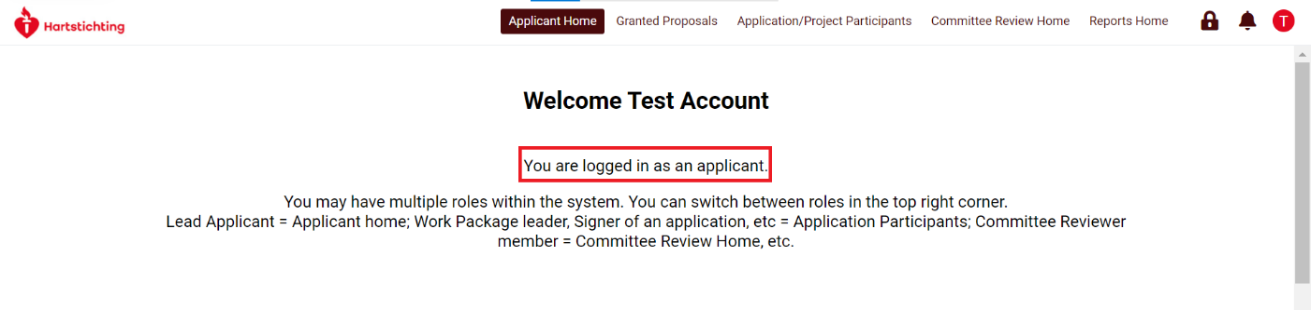

If you are an applicant you can find your (pre)applications by navigating to the ‘Applicant Home’ page. In addition, all requested rebuttals can be found here.

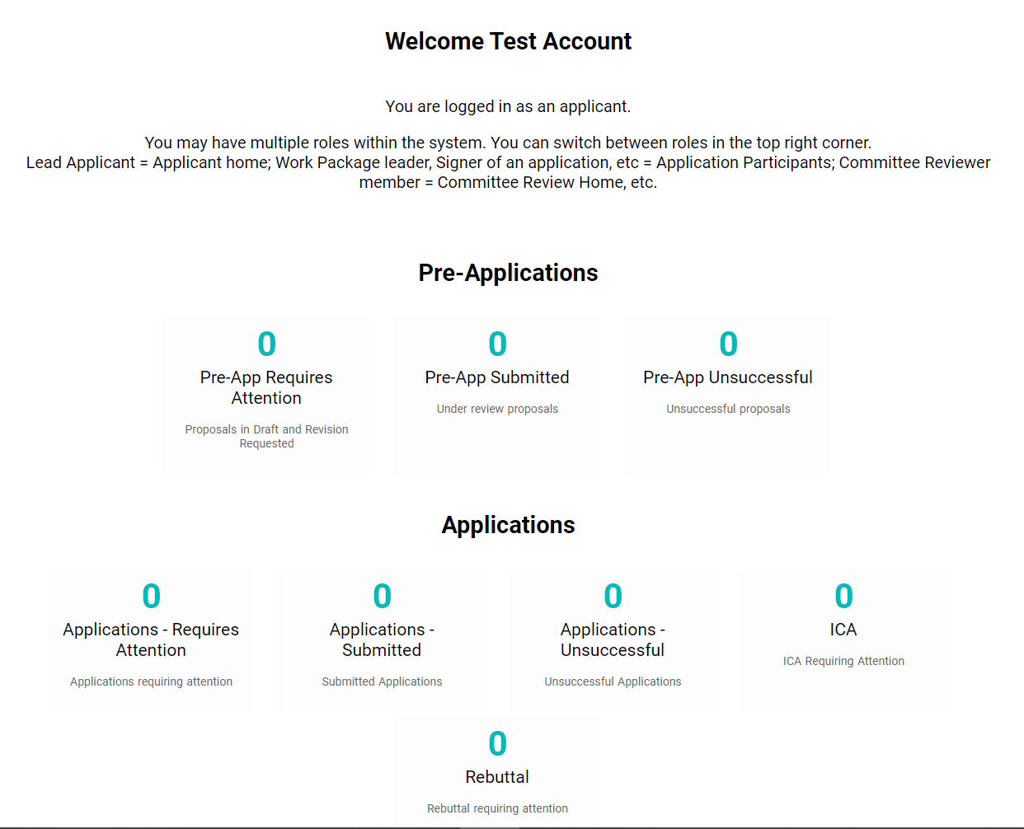

When you scroll down, you will find a list of Open and Invited Calls.

Invited calls are only open for invitees.

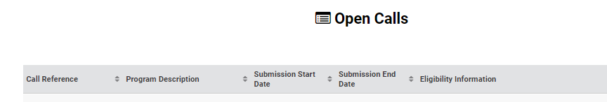

# Dashboard Granted Proposals

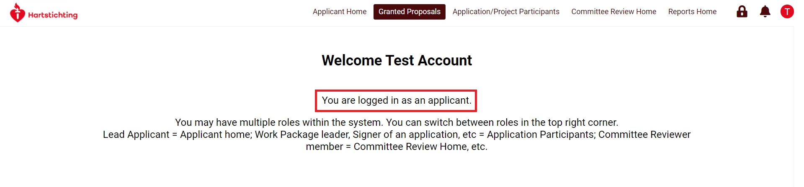

If you are an applicant you will find your granted proposals by navigating to the ‘Granted Proposal’ page. All provisionally granted proposals, granted projects (after final granting of a proposal) and closed projects can be found here.

When you scroll down you can find a list of the Change Requests you have requested. You can also find the output that was uploaded (see other instructions).

# Dashboard Application/Project participants

If you are an co-applicant or any other role besides lead applicant (work package leader, signer of an application etc.) you can find a list of all applications where your name appears in these roles on the tab ‘Application/Project participants’. When you navigate to the page ‘Requires Signatures’, you can find a list of applications which require your signature.

A number of listviews are visible when you scroll down, for instance:

* Listviews of all applications which are assigned to you in the different role. Note: the applicant here represents the role of co-applicant, not lead-applicant.
* Listviews of all granted proposals (now called projects), including personnel appointed and their activities.
* Listviews of reports assigned to projects in which you are a participant.
* Listviews of changes requested, approved or rejected of projects in which you are a participant.
* Listviews of output uploaded, in progress or approved of projects in which you are a participant.

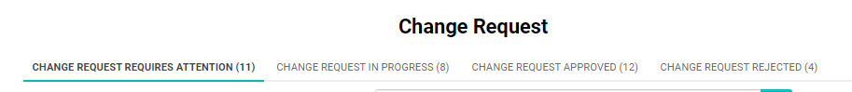

# Dashboard Committee Review Home

If you are asked to review an application or report as a committee member you will find all applications and projects where your name appears in this role on this page.

First we ask you to do a Conflict of Interest Check. Furthermore there are listview for reviews in progress, reviews submitted and reviews for which you had a conflict of interest.

If you click on one of the list views you can see in the column ‘Type’ which type of Review we request from you.

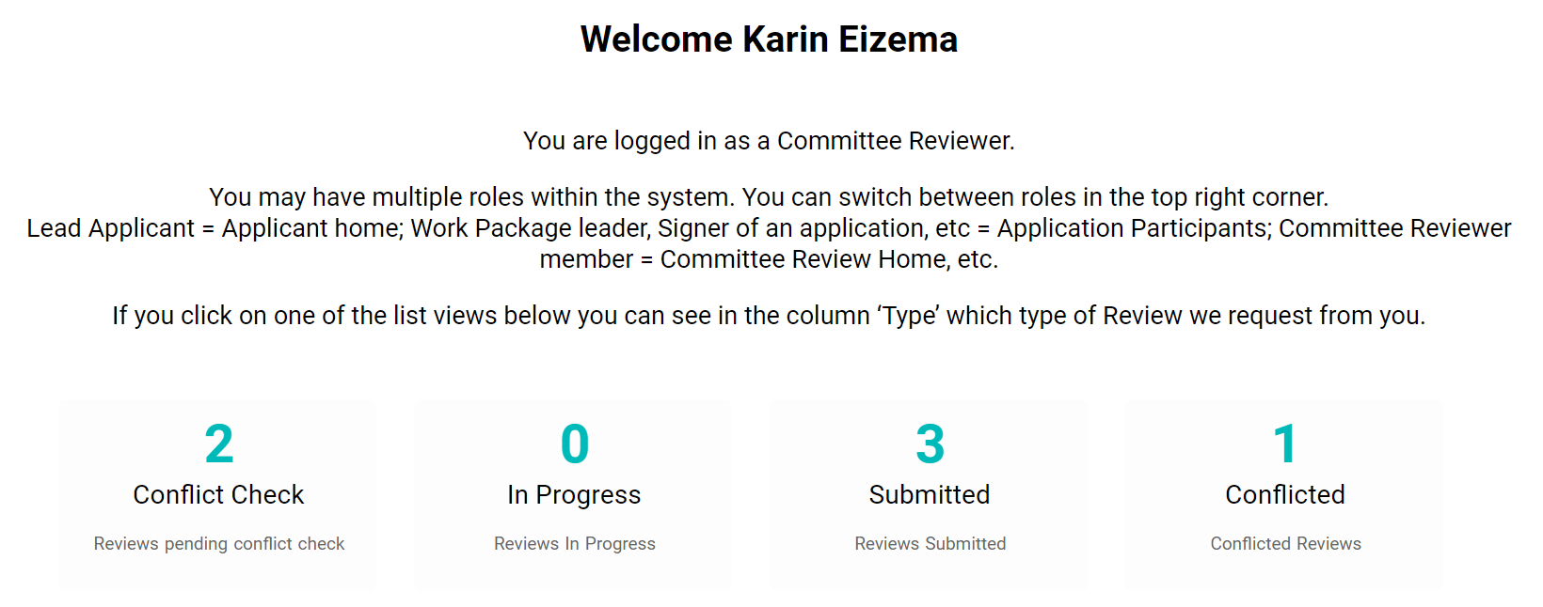

# Dashboard Reviews

If you are asked to review an application or report as an external reviewer (not as a committee reviewer) you will find all applications and projects where your name appears in this role on this page.

First we ask you to do a Conflict of Interest Check. Furthermore there are listview for reviews in progress (requiring attention) and submitted reviews.

If you click on one of the list views you can see in the column ‘Type’ which type of Review we request from you.

# Dashboard Reports Home

If you are an applicant you will find your reports here. Reports which are soon expected from you (pending), reports not yet submitted or which need to be adjusted (requiring attention), rebuttals given on reports, reports in progress, approved or rejected can be found here.

If you click on one of the list views you can see in the column ‘Type’ what kind of report it is and in the column ‘Status’ what the status of a report is.

