SIGNING OF AN APPLICATION BY A SIGNER NOT BEING AN APPLICANT

Accept invitation to be a signer
You have received an email of the applicant to become a signer of his application. Please open the link in the email and accept or decline this invitation

Signing an application after creating an account
After accepting the invitation you can log into your signer account, navigate to the ‘Application/Project Participants’ section, by clicking on this specific tab.

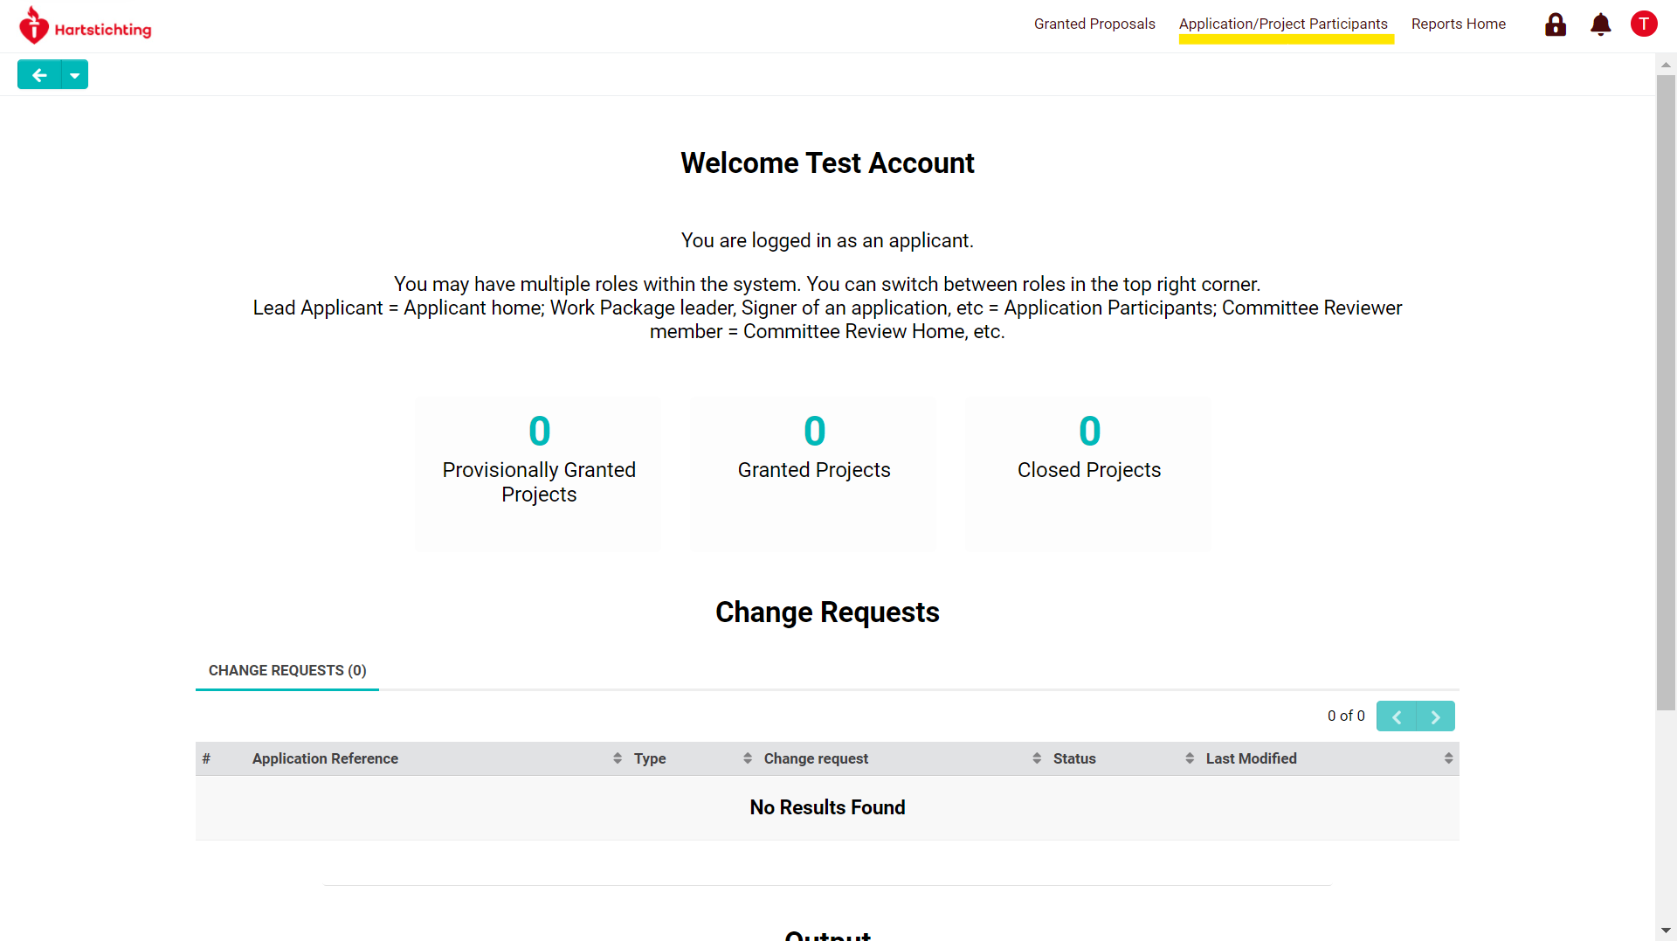

Next, navigate and click on the button ‘Requires Signatures’.
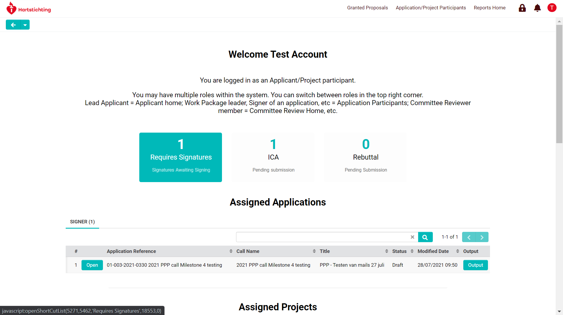
Under Requires Signatures you will find the application(s) which require(s) your signature as project participant. Click on the ‘Open’ button to navigate to the signing page.

Click on the ‘Sign’ button to sign the application.

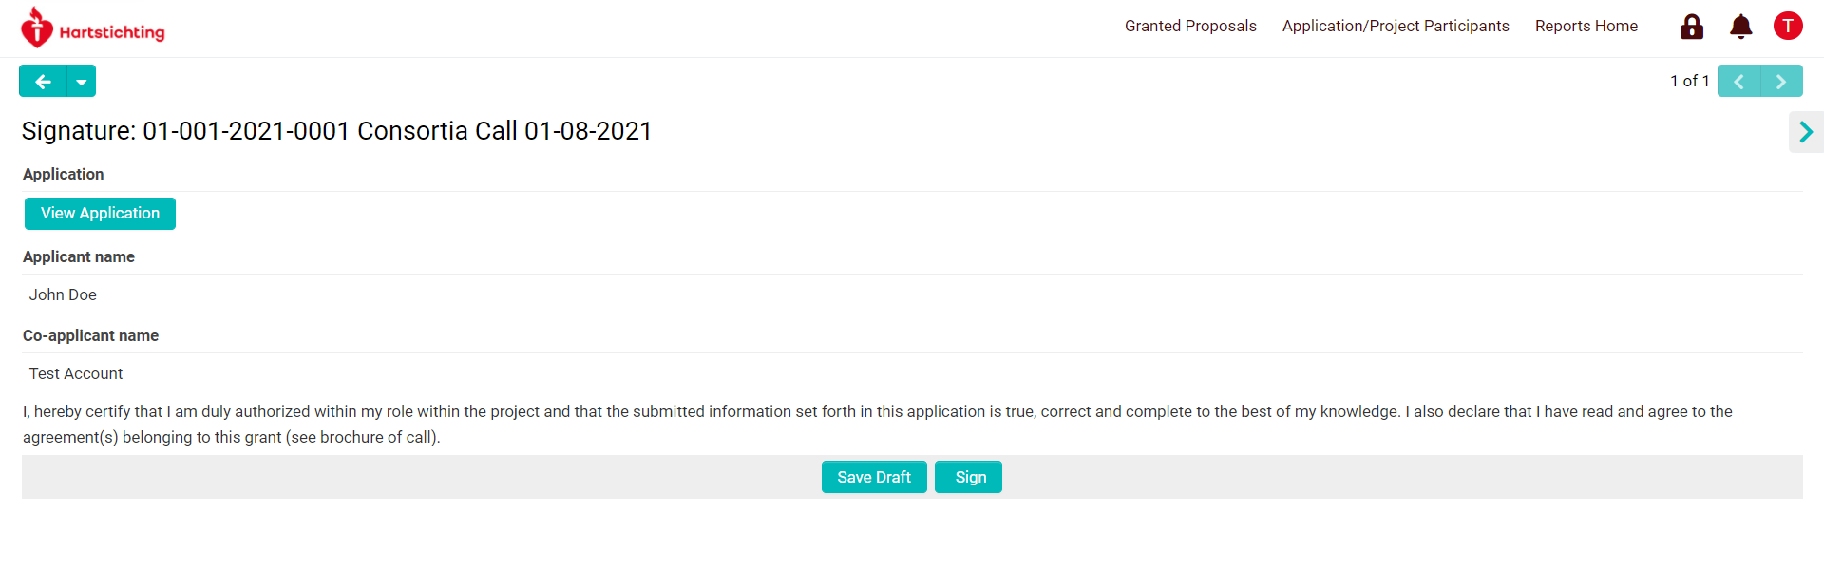
After successfully signing the application, you will see a message confirming your action.

The application has been successfully signed with your name. The applicant can now proceed with the next steps in his/her application process.

