Changes/additions to the project: CHANGE REQUEST

In an ongoing research project changes or additions will be necessary. As agreed on within the grant agreement it is mandatory to provide the correct information about the project and its personnel appointed.
Please submit a change request when you want to change or add:
- the lead applicant
- the second applicant
- one of the partners
- personnel appointed
- budget (the requested budget, not spenditure)
- duration of the project
- other deviations.
New to our procedure is that change requests now have to be presented to the DHF online via our grant management system www.cavaris.nl. By this procedure we ensure that the correct information is entered in the system. You can submit your request for changes within your application for the categories mentioned here above. If you would like to change lead applicant, applicant or add a partner or add personnel appointed you first have to invite these people via the left menu Invitations. For each change you must submit a request and per request only 1 person can be changed.
Please note that depending on the role you have within the application you can locate the application of interest in different portals.
Lead applicant/ applicant: Portal Granted proposals
WP Leader/ Project manager/ personnel appointed: Portal Application/Project partcipants
The (lead) applicant, wp leader, project manager and the talent coordinator can start and edit a change request.
Please note that only the Lead Applicant and the Applicant can submit the change request!

Submitting a change request general procedure
If you are an Lead Applicant:
Please log into your account, open your dashboard and choose Granted Proposals.
On this page choose Granted Projects. Navigate through your list of granted projects, find the correct Application Reference and choose Change Request.
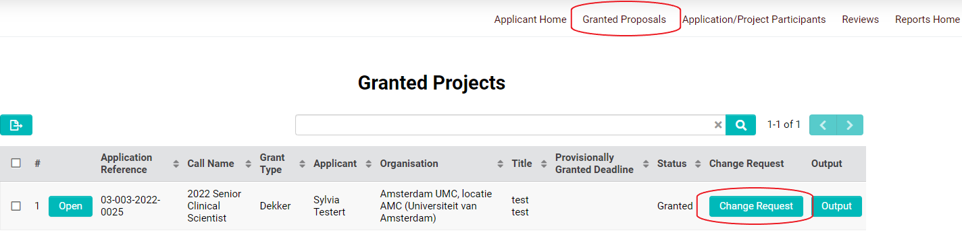

- Choose the change you like to report.
- Click the Save Draft button in order to see the specific question belonging to the requested change.
- Please fill in all required details. Click the Save Draft button to save the information when you will not be submitting your request right away .
- 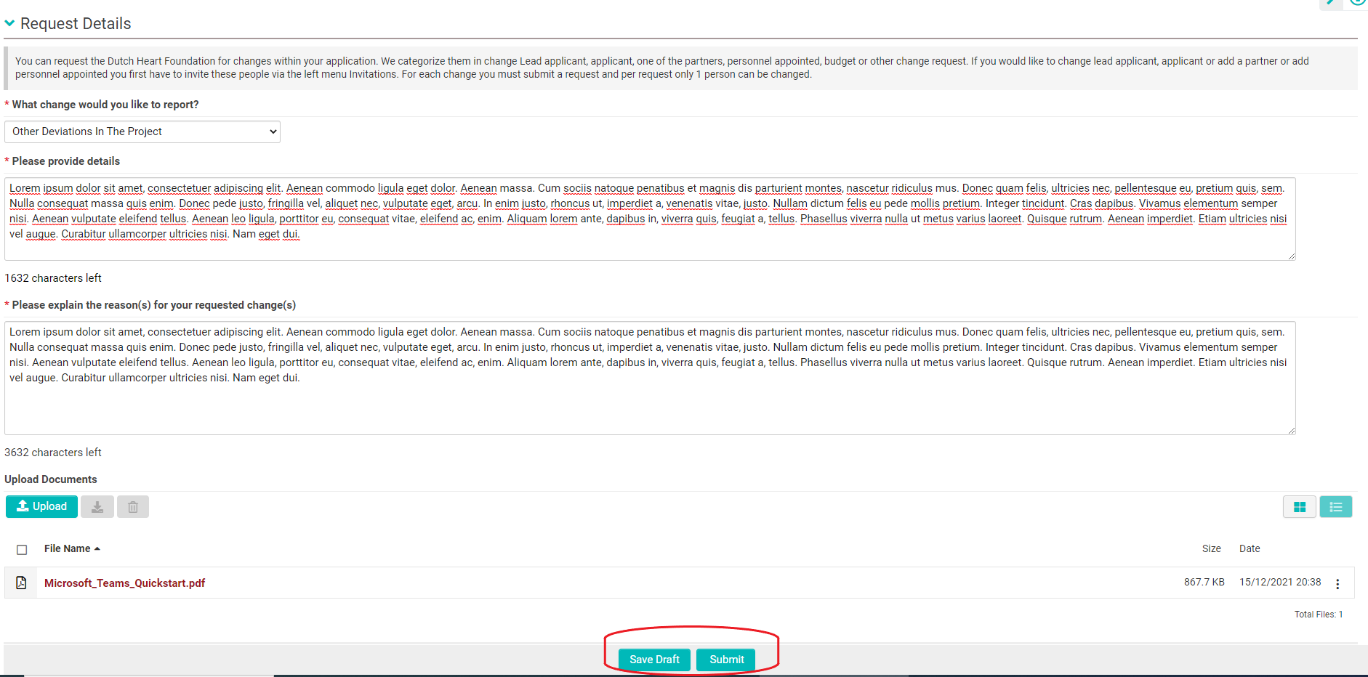Submit the change request using the Submit button. Your request is now sent to one of our staff members who will review it.
- After your request is looked into, we will either approve it and send you the confirmation by email or we will ask for additional information. In case of the latter, please edit and re-submit your request.
- On the main page of Granted Proposals you will find an overview of submitted Change Request and their status.
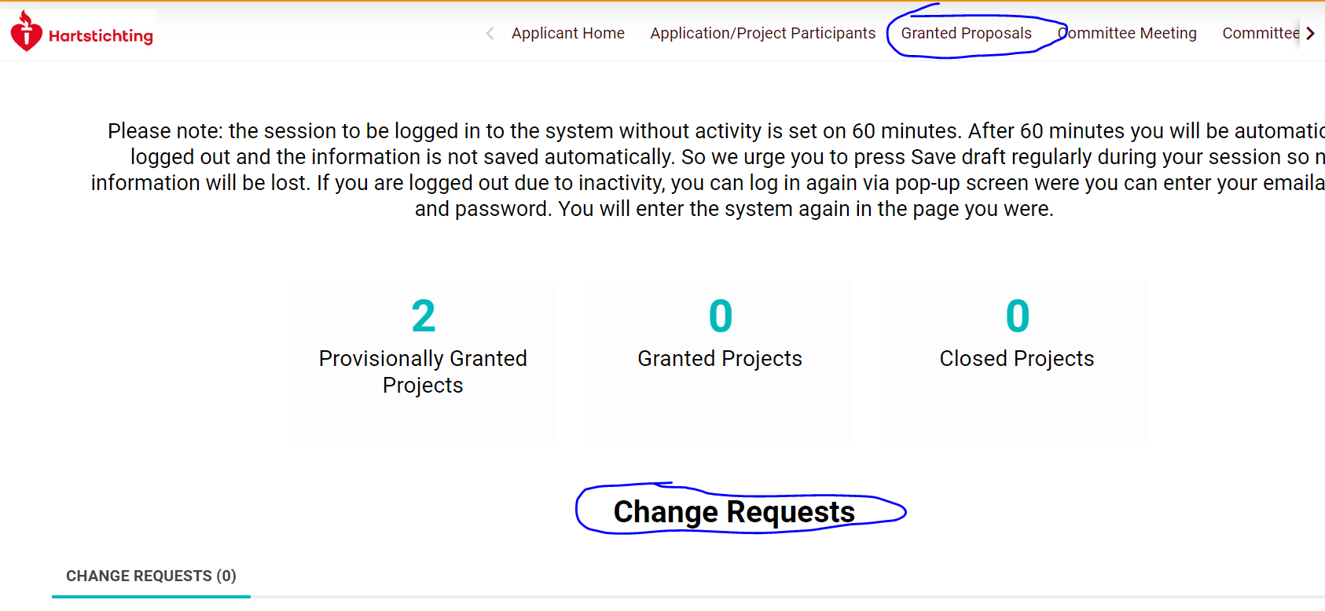

If you are an applicant/project participant (wp leader, project manager etc):
If you are not the Lead Applicant you will find the projects where you are involved with under Application/Project Participants. Scroll down to Assigned projects, find the correct Application Reference and choose Change Request.
- Please fill in all required details. Click the Save Draft button to save the information.
- Only the Lead Applicant and the Applicant can submit the change request!
- On the main page of Application/Project Participants you will find an overview of submitted Change Request and their status (scroll down).

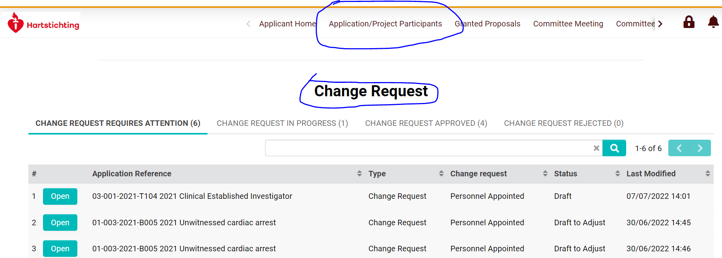
1. Change request Lead Applicant
If the Lead Applicant is going to change you use this change request. Please note that this change will generally lead to an amendment of the legal documents. Since this will take time please inform us as soon as possible.

2. Change request Second Applicant
If the Second Applicant (in the system also called Applicant) is going to change you use this change request. Please note that this change will generally lead to an amendment of the legal documents. Since this will take time please inform us as soon as possible.

3. Change request One of the Partners
- If you would like to make changes to an Academic Partner, please select "One Of The Partners" then choose "Academic Partners".
- If you would like to make changes to Private Partners, please select "One Of The Partners" then choose "Private Partners".
- If you would like to make changes to Stakeholder or Public partner or End user partners, please select "One Of The Partners" then choose "Stakeholders".
Please note that this change will generally lead to an amendment of the legal documents. Since this will take time please inform us as soon as possible.
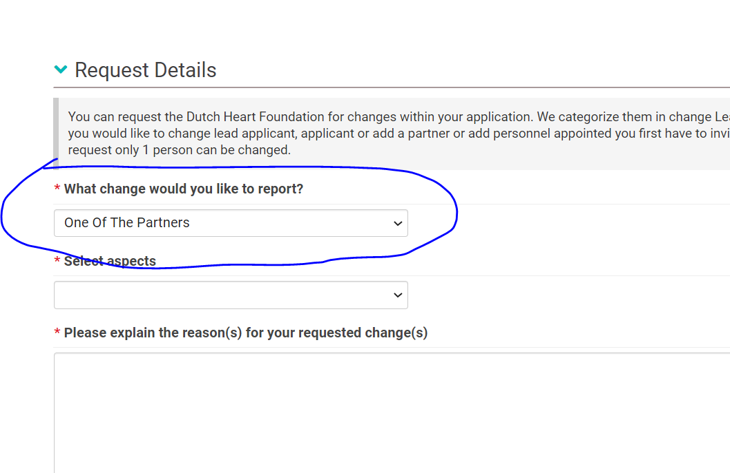
4. Change request Personnel Appointed
Once your project has been approved by the DHF, you can only add or change personnel working on the project through a change request. If you add personnel you have to invite this person using the invitations tab on the left side. Personnel added this way will have access to the project, reports etc. Please note that you have to submit a new request for every person appointed:

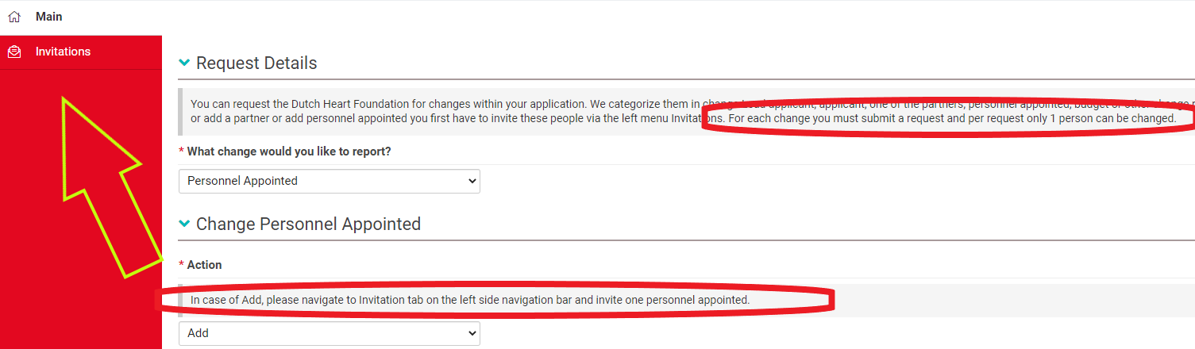

When you invite a person to your project, note that you can only submit the change request once he or she has accepted the invitation.

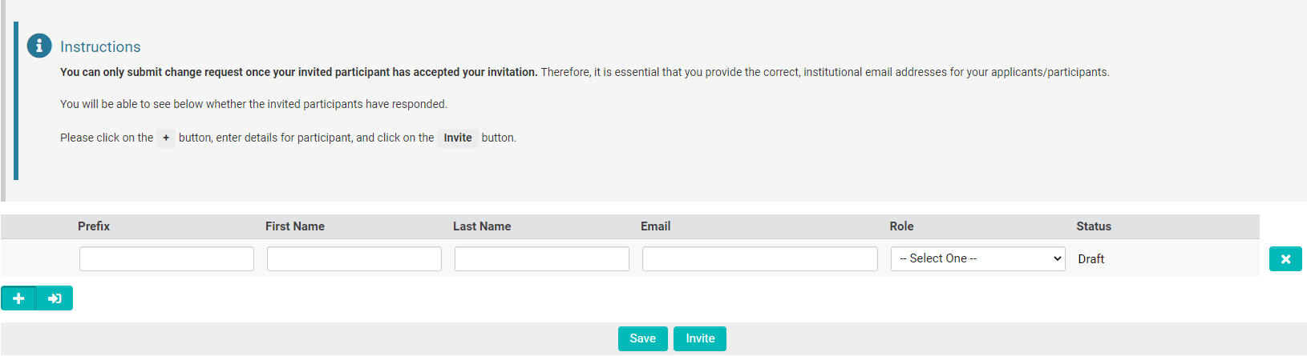

After you have invited a person, choose Proceed to Details.
You can fill in the details only after the added person has accepted your invitation.

Important:
- When staff or also an applicant or project partner is no longer working on a project their role changes to ‘historic’ and this person has no longer access to the application.
- Because of the transition from old to new system all project group members and appointed staff of old projects have been given the role of historic because we did not wanted to give them unsolicited access to the application. For projects that are still ongoing, we will coordinate this with the relevant applicants to determine who can be granted access to the application.

5. Change request Extension of Duration
If you would like to extent the duration of the project use this change request. Describe extensively the background of the request. Please note that this change can lead to an amendment of the legal documents or an amendment of the payments. Since this will take time please inform us as soon as possible.
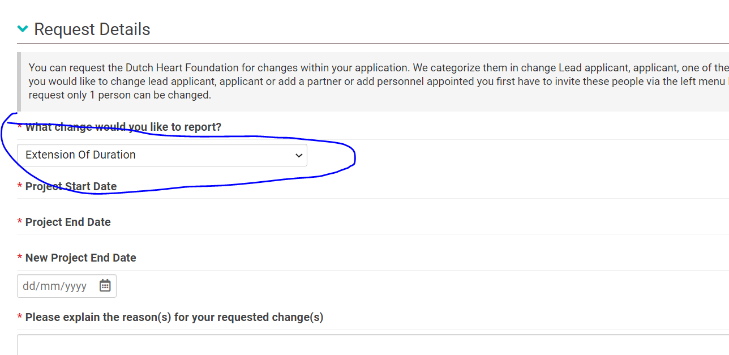
6. Change request Budget Changes
If you would like to change something in the budget as requested while applying for the grant use this change request. You will need to upload a new budget sheet. This is only for changes to the requested budget. Financial reports with the actual costs are findable in the project under the tab Monitoring.

7. Change request Other Deviations in The Project
If you would like to change something which does not fit in either of the above categories use this change request.

