Output of the project OUTPUT ACTIVITY

It is important for the Dutch Heart Foundation to be able to analyze the impact of projects financed by us. Like other funding organizations, we are accountable to our stakeholders, and therefore we need to monitor the outcomes of the research we fund on a regular basis. It is also important that we can provide our supporters with evidence that the research we fund is translated into advances for patients.
To monitor the impact generated by a project all activities concern knowledge transfer moments are important. Besides publications also e.g., established datasets and databases, intellectual property, policy paper, further funding and awards also add to the impact of your project. Therefor we kindly request to register the output of a project within our grant management system.

Only add Output that is DIRECTLY related with the results from this project.
For example: visits to conferences where no results of the project are presented do not have to be reported.

Impact areas
In the system different Impact areas and Indicators are defined. See the table below.

Impact areas |  | Indicators
1 | Generating new knowledge | 1.1 Publications
 |  | 1.2 Conference
 |  | 1.3 Research tools and methods
 |  | 1.4 Research databases and models
2 | Translating research ideas into new products and services | 2.1 Intellectual property and licensing
 |  | 2.2 Spin out companies
 |  | 2.3 Medical products, interventions and clinical trials
 |  | 2.4 Software and technical products
 |  | 2.5 Artistic & Creative Products
 |  | 2.6 Other outputs & knowledge / future steps
3 | Creating evidence that will influence policy or other stakeholders | 3.1 Influence on policy, practice, patients and the public
 |  | 3.2 Engagement activities
4 | Stimulating further research via new funding or partnerships | 4.1 Further funding
 |  | 4.2 Collaborations and partnerships
5 | Awards and recognition | 5.1 Awards and recognition

How to register an output?
All output activity can be registered by applicants of the project. You have to submit a separate entry for every output. Uploading output can be done anytime during the duration of the project and also when your project is ‘closed’ after the end date. It is mandatory to provide the correct information about the project and its output.
Please note: for publications it is mandatory that the DHF with the grant number is mentioned, otherwise we will discard the output. Also the other outputs must have a direct link with the project otherwise we will discard this output.

Please note that only the (Lead) applicant can submit an Output Activity

Submitting Output Activity
If you are an Lead Applicant:
Please log into your account, open your dashboard and choose Granted Proposals. On this page choose Granted Projects. Navigate through your list of granted projects, find the correct Application Reference and choose Output.
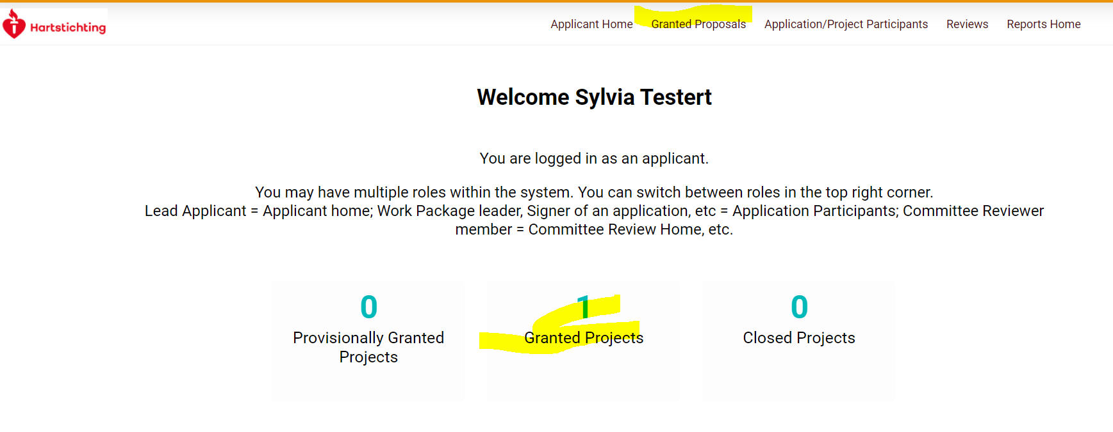
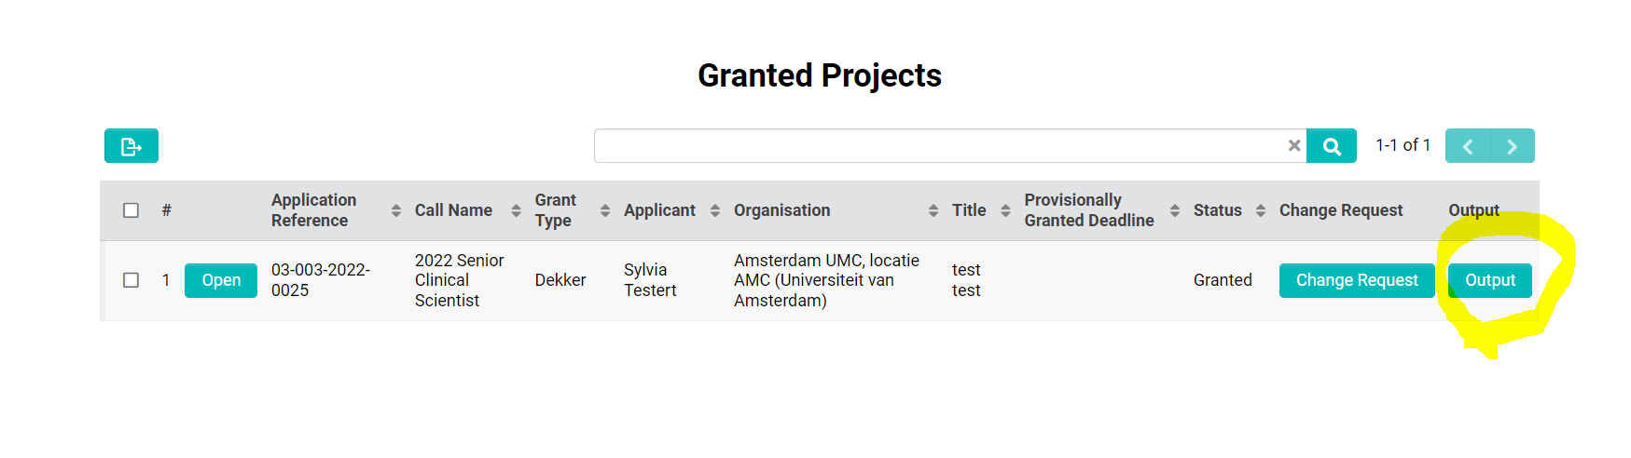If you are an applicant/project participant (wp leader, project manager etc):
If you are not the Lead Applicant you will find the projects where you are involved with under Application/Project Participants. Scroll down to Assigned projects, find the correct Application Reference and choose Output.

- Please fill in the correct impact area and indicator.
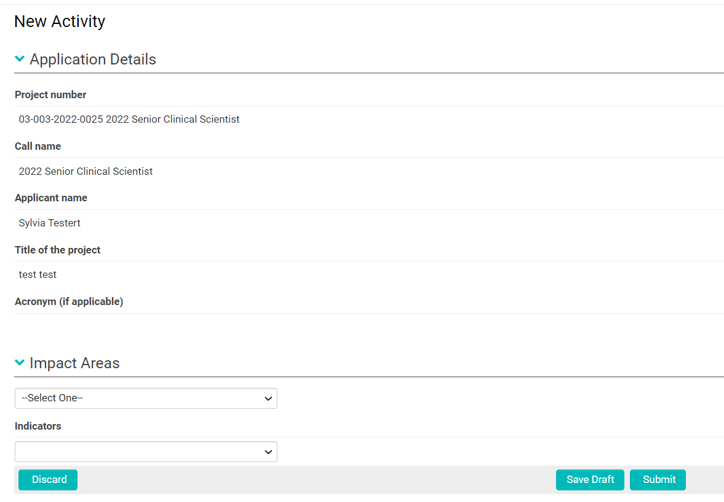
- Note: Only after clicking the Save Draft button you are able to enter information about the activity itself (e.g. details of the publication)
- Click Save Draft when you will not be submitting your output right away
- Submit the Output Activity using the Submit button. Your request is now sent to one of our staff members who will review it.
- After your request is looked into, we will either approve, we will ask for additional information or discard it. After approval no confirmation is send. If we ask for additional information you will receive an email. In case of the latter, please edit and re-submit your activity. If we decide to discard your Output Activity no automatic email will be send. If we notice that several publications are entered without mentioning the DHF we will discuss this with the applicant.
- On the main page of Granted Proposals (if you are a Lead Applicant) or on the main page of Application/Project Participants (scroll down) you will find an overview of submitted Output and their status.

Alternative route: If you are writing a report you can also upload Output Activity. Please note that you leave the report if you choose for uploading Output Activity.
Please save your report before you choose to fill in an Output Activity.
After uploading the Output Activity you have to reopen the report from the monitoring tab in your granted project.

